Dear Fellow Patient

Thank you for agreeing to join the Central Surgery Patient Participation Group.

The purpose of the group is to keep you in touch with local developments in the National Health Service in general and at the Central Surgery in particular, and to invite your comments on the service from your experience. Any comments you make will help improve the service.

I am sure you are aware that the National Health Service is undergoing fundamental change. Although legislation has passed through Parliament, many of the details of how things will work are still being sorted out.

You will be aware that GPs are to be given the budget to commission health services from providers like Southend Hospital. In Southend GP surgeries have formed the Estuary Commissioning Group to undertake these responsibilities.

Many surgeries have Patient Participation Groups like ours but all are now encouraged to widen the scope of participation, to gain the views of patients and to send a representative to the Estuary Patient Commissioning Group that will meet every couple of months. At present I am the Central Surgery representative on that group and can feed back progress to you by Email and through the Patient Participation Group that meets every couple of months at the surgery. You would be welcome to drop in if you have the time.

Christine Lloyd the Surgery Practice Manager, acts as Secretary to our group and will keep in touch with up to date news. You will have received a report from a Patient Survey recently conducted by the Surgery.

We will try to keep you informed but if you have any questions or comments on the service you receive; please get in touch via Christine whose contact details are below.

I hope this is useful.

Yours sincerely

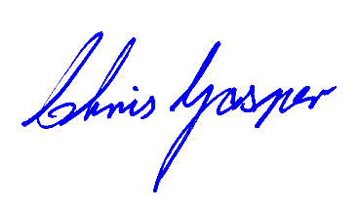

Chair

Central Surgery Patient Participation Group