Central Surgery – Patient Participation Group
Thank you for allowing the surgery to consult you on the local workings of the Health Service for which Central Surgery is usually your initial contact. The purpose of the Patient Participation Group (PPG) is to keep patients informed of developments in the surgery and other Health Services in which you may become involved. It also invites comments and suggestions to improve services.
As many patients are unable to attend day-time meetings, we maintain a “Virtual Group” to contact through Email to keep you informed and invite response. If you would rather not receive occasional information from us, please contact Practice Manager Christine Lloyd, admin.mailboxf81086@nhs.net 01702 468443 who will remove you from the contact list.
I have been a member of Central Surgery PPG for some time and currently represent the Group on the Southend Clinical Commissioning Group Patient Participation Forum. I am also connected with Southend Healthwatch and am a friend of Southend University Hospital.
The Surgery has recently submitted a report on the activity to NHS England of the PPG. A copy of the report is available on the Surgery Website under the tag for “Practice News” / “Patient Participation Group”
http://www.central-surgery.co.uk/News/91e9b9ad-b281-4528-88e2-8b873bf87624
In gathering information on the age range of surgery patients compared with that of the PPG, it was found that young patients are underrepresented.
Essex Healthwatch (that covers all Essex with the exception of Southend and Thurrock who have unitary authorities) has published a report on the experiences of Essex young people that underlines some of the problems, found by those from this age group in accessing NHS services. A copy of the report is available to download from the Surgery Website, under “Practice News”, “Healthwatch Essex The Yeah! Report.” http://www.central-surgery.co.uk/News
If you fall into this age group I hope that you’ll find it relevant and informative. If you have access to young people who may have interest in it, I would be grateful if you could forward the report to them. The Surgery and the PPG would be most interested in any comments you have on the report, especially if they refer to the work of Central Surgery. Practice Manager Christine Lloyd would like to receive comments, in confidence that can be considered by a future meeting of the Patient Participation Group. Admin.mailboxf81086@nhs.net 01702 468443.
Our next meeting has been arranged for 1.00 PM on Monday 13 July 2015 at Central Surgery. If you are able to attend the meeting, it would be good to meet you. Please let the surgery know for numbers purposes. If you have an issue you would like us to discuss, please let Christine know.
Thanks you for your involvement.
Yours sincerely
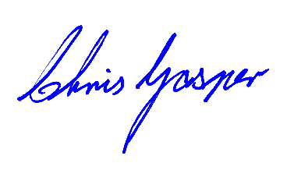
Chris Gasper
Chair of Central Surgery PPG

