#SUPPORT
A group for family, friends & carers who are supporting loved
ones who are affected by mental illness.
Sharing ideas
Information & guidance
Relaxed & friendly
Atmosphere

Making connections & building friendships and trust
You are not alone

Local group
Non judgemental
Help & advice

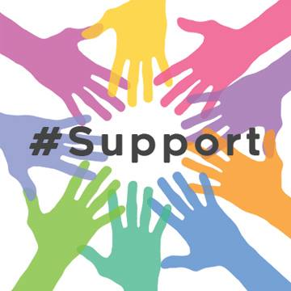
Please come along and share ideas, experiences & support others that are in need or just sit back, enjoy a coffee and relax in a safe and friendly space.

DATES – Tuesday 11th June – Wednesday 10th July – Tuesday 13th August Wednesday 11th September
TIME – Drop in any time between 7pm and 9pm
PLACE –Utopia coffee lounge
Unit 2 The Royals, Heygate Ave, Southend –on-sea SS1 1DQ
www.facebook.com/hashtagsupport (Email) hashtagsupport@protonmail.com

